**Class Test CS473- Computer Vision**

**Name of Students: Abhishek Singh Kunwar**

**SAP ID: 1000008446**

**Roll No: 170102316**

Max Marks = 10. Time: 45 Min

**Questions:**

Q1.**MCQs/ True or False**(5x1)

(i) Consider and image with width and height as 100×400. Each pixel in the image can have a color from Grayscale, i.e. values. How much space would this image require for storing?**[Note: No compression is done]**

(A) 2,56,00,000

(B) 90,60,000

(C) None of the above

(D) 320000

(ii) What is Digitization of Spatial Co-Ordinates (X, Y) Called

(A)Gray Level Quantization

(B)Finite Sampling

(C)Image Sampling

(D)Image Quantization

(iii) Which of the following is an application of Image segmentaion?

(A) K-Mans

(B) registering

(C) None of the Above

(D) A and B

(iv) The higher number of pixels will result in a better image than the image with lower numbers of pixels. **TRUE/FALSE**?

(v) Smaller Aperture in a digital camera will produce a more blurred background image than the larger Aperture size. **TRUE/FALSE**?

Q2. Differentiate between Image Classification and Image Localization. (2.5)

Q3. List down any three applications of computer vision in business industries and briefly explain your point of viewson how Computer vision is applicable in the business. (2.5)

NOTE: rename the file as “FirstName_LastName_SAPID” and upload (word/pdf).

**Solutions/Answers:**

Ans 1.

(i) (D) 320000

(ii) (C)Image Sampling

(iii) (D) A and B

(iv) **TRUE**

(v) **FALSE**

Ans 2.

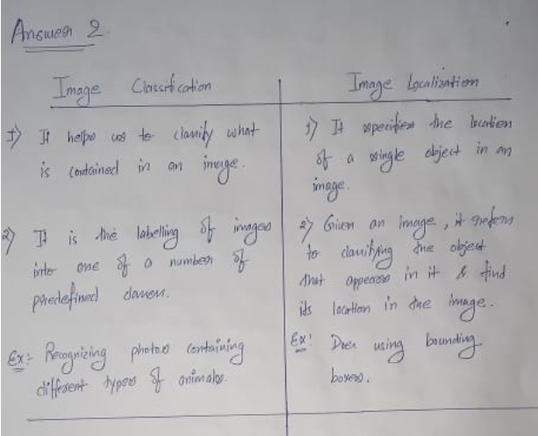

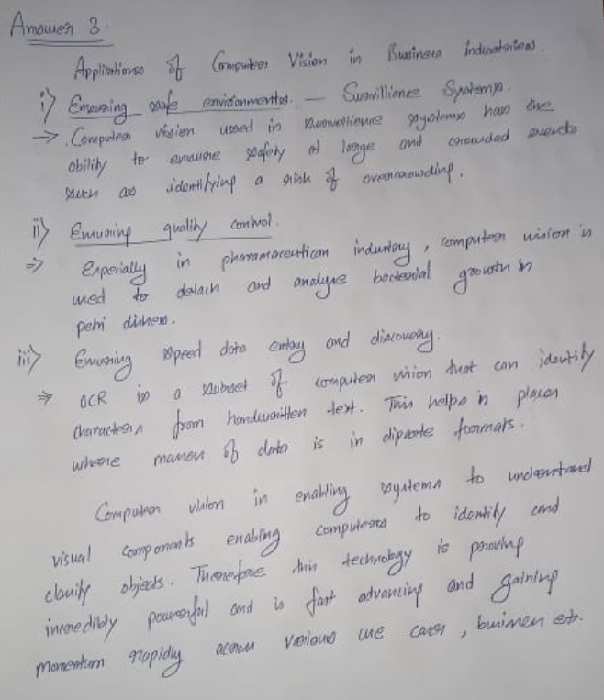Ans 3.